Seizure info MA

The information given was based on the original file that lasted more than 20 minutes. These files only last about 7 minutes (5 minutes before seizure and 2 minutes after seizure). So, from the time of the onset of the seizure, deduct 5 minutes and this is your new beginning of the file.

SZ1 | Beginning:7:59:52  Ending:8:30:58 | Onset:8:24:39  Offset:8:26:20
SZ2 | Beginning:1:43:50  Ending:2:10:06 | Onset:2:03:34  Offset:2:05:07
SZ3 | Beginning:4:51:50  Ending:5:22:12 | Onset:5:16:38  Offset:5:18:57
SZ4 | Beginning:5:56:03  Ending:6:26:35 | Onset:6:19:52  Offset:6:22:16
SZ5 | Beginning: 8:04:26  Ending:8:27:44 | Onset:8:24:47  Offset:8:26:47

Only the first 20 electrodes
SR=500Hz

SZ 1: SPIKES

08:20:58 (15)-MAX
* 08:21:31 (15)-MAX
08:24:33 (15)-MAX
08:24:28 (15)-MAX
08:24:08 (15)-MAX
08:24:00 (15)-MAX
08:23:55 (15)-MAX
08:23:43 (15)-MAX
08:22:59 (15)-MAX

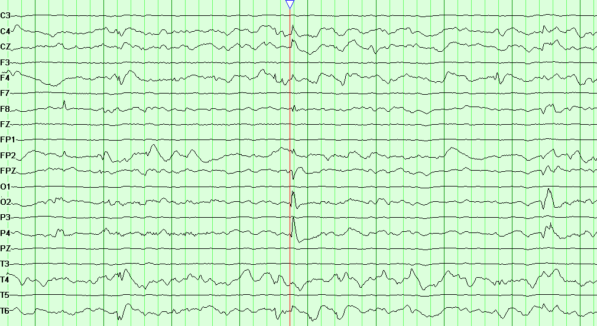
Note: ** 08:21:31 (15)-MAX

